31/07/24

Boot-java development with spring framework. Spring Boot and Maven work together to simplify Java application development, dependency management, build processes, and deployment. Spring Boot leverages Maven's powerful dependency management and build capabilities, while Maven provides the structure and automation needed to build and manage Spring Boot applications effectively. By using these tools together, developers can streamline their workflows and focus on writing code rather than managing configuration and dependencies.

Jenkins-timely integrations and build it, make your application updated.

Docker-the project is converted into an image.

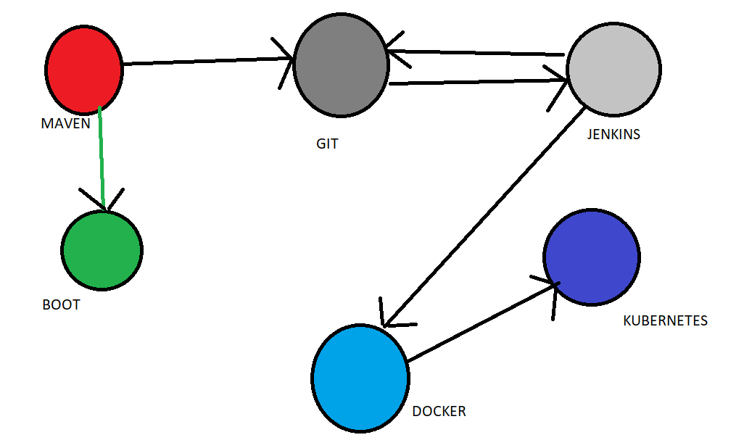

[Getting Started with Java Message Service (JMS) (oracle.com)](https://www.oracle.com/technical-resources/articles/java/intro-java-message-service.html)

RabbitMQ is a reliable and mature messaging and streaming broker, which is easy to deploy on cloud environments, on-premises, and on your local machine.--> [RabbitMQ: One broker to queue them all | RabbitMQ](https://www.rabbitmq.com/)

[Apache Kafka](https://kafka.apache.org/documentation/)

Spring Batch Self-learning: [Spring Batch](https://spring.io/projects/spring-batch)

AWS:

